**Git Workflow:**

We can store the code in repository.

**Working Directory:**

All the files are untracked in this stage.

**Staging Area:**

* We can send the files or code to the staging area by using **“git add filename” or “git add . ”** command.
* All the files are tracked in this stage.

**Local Repository:**

We can push the changes to the local repo from staging area by using **“git commit -m “commit message” “** command.

**Remote Repository:**

We can push the changes from local repo to remote repo by using “**git push repositoryurl”** command.

**GIT Commands:**

**Git clone repositoryurl:**

This command will download the entire repository from remote repo into the local repo.

**Git Pull repourl:**

This command will download the only modified files from remote repo into the local repo.

**Git Log:**

This command is used to display the commit history like commit id,commit message,author name,date.

**Git log --oneline:**

This command is used to display the one line only like commit id,commit message.

**Git log --1:**

This command is used to display the latest commit history.

**git Config --global user.name “username”:**

This command is used to configure the git in our local system.

**git remote add origin remoterepositoryurl:**

This command is used to add the remote repo to the local repo.It will establish connection b/w local and remote repo.

(Instead of **origin** we can also give any name in the above command)

**Git remote -v:**

It will list the remote repository url.

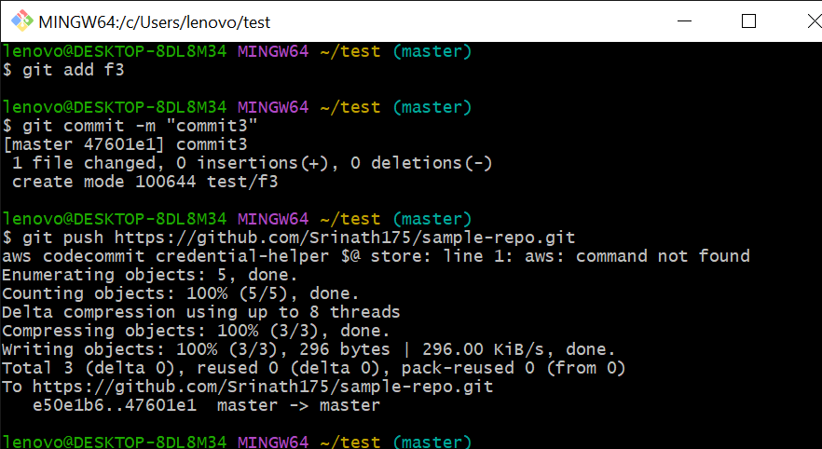

**Git Merge:**

This command is used to merge the changes from one branch to another branch.

First we need to switched to the branch( to which branch we want to merge the changes)

We need to execute the **git merge branchname** command( here we need to specify the branch name from which branch we want to merge the changes).

**Git cherry-pick commit_id:**

This command is used to merge the particular commit from one branch to another branch

**Git Fetch:**

This command is used to download the modified files from remote repo to local repo but not downloaded into working directory.

We need to use **git merge** command after the **git fetch** command to download the modified files into working directory.

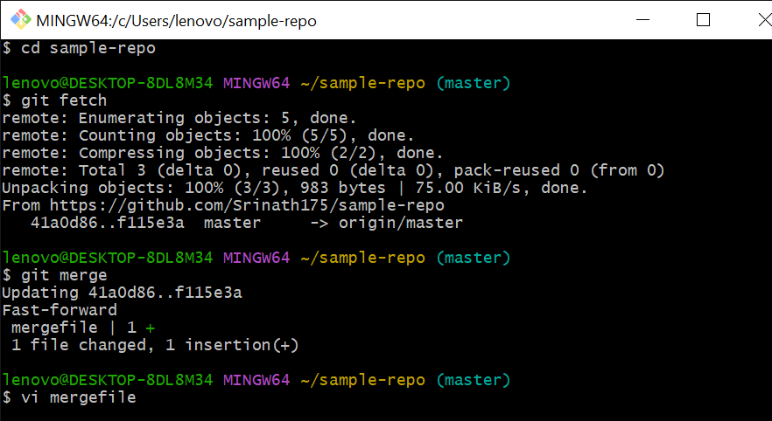

**Git branch branchname:**

This command is used to create the new branch.

**Git checkout branchname** :

This command is used to switched to the particular branch.

**Git rebase command:**

It is also used to merge the changes from one branch to another branch.

**Difference b/w Git merge and Git rebase:**

When we use the **git merge** command it will create the one extra commit or new commit(merge commit) which represents the merge has happened.

Whereas when we use **git rebase** command it will not create the extra commit(merge commit).